CPE301 – SPRING 2019

Design Assignment 4B

Student Name: Rocky Yasuaki Gonzalez

Student #: 5003229733

Student Email: gonzar14@unlv.nevada.edu

Primary Github address: https://github.com/rockyg1995/ihswppdar.git

Directory: C:\Users\rocky\Documents\CpE 301+L - Embedded Systems Design\CpE

301\Repository\DesignAssignments\DA4B

Submit the following for all Labs:

1. In the document, for each task submit the modified or included code (only) with highlights and justifications of the modifications. Also, include the comments.
2. Use the previously create a Github repository with a random name (no CPE/301, Lastname, Firstname). Place all labs under the root folder ESD301/DA, sub-folder named LABXX, with one document and one video link file for each lab, place modified asm/c files named as LabXX-TYY.asm/c.
3. If multiple asm/c files or other libraries are used, create a folder LabXX-TYY and place these files inside the folder.
4. The folder should have a) Word document (see template), b) source code file(s) and other include files, c) text file with youtube video links (see template).

1. **COMPONENTS LIST AND FLOW DIAGRAMS**

Atmega328PB Xplained Mini

Micro USB Cable (Power Supply)

Breadboard

Multifunction Shield (Potentiometer)

ULN2003 w/ LEDs

Stepper Motor

Servo Motor

Female to Female Wires

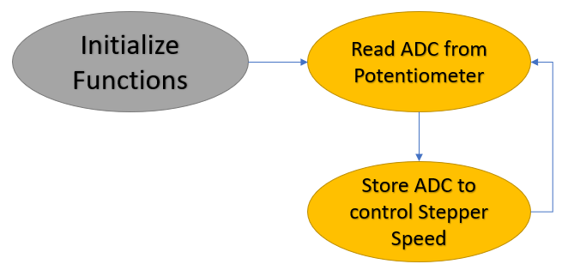

*Figure 1 – Flow Chart for Coding Algorithm in Task 1*

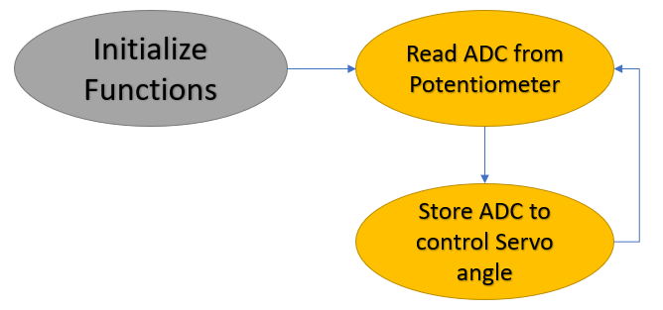

*Figure 2 – Flow Chart for Coding Algorithm in Task 2*

1. **INITIAL/DEVELOPED CODE OF TASK 1**

/*

* DA4B_Task_1.c

*

* Created: 4/13/2019 3:36:09 PM

* Author: RYG95

*/

#define *F_CPU* 16000000UL // Frequency of Xplained Mini (16MHz)

#include <avr/io.h> // Standard AVR Library

#include <stdio.h> // AVR library containing printf functions

#include <avr/interrupt.h> // AVR library containing interrupt functions

#include <util/delay.h> // AVR library containing _delay_ms() function

#define BAUDRATE 9600 // Baudrate (bps)

#define BAUD_PRESCALLER ((*F_CPU* / (BAUDRATE * 16UL)) - 1) // Baudrate Prescaler

void Timer0_init(void); // Initialize Timer1 properties

void adc_init(void); // Initialize Analog to Digital Converter

void read_adc(void); // Read value from ADC

void USART_init(void); // Initialize USART

unsigned char USART_receive(void); // Receive Serial data from UDR0

void USART_send(unsigned char data); // Send individual char in UDR0

void USART_putstring(char* StringPtr); // Break string into chars and send

volatile float adc_val; // Store ADC Value representing Analog Voltage

char outs[20]; // Store float values into array of chars

int main(void) {

DDRC = 0x00; // Inputs: PC7:0 (PC0 Input ADC, PC1 Switch)

PORTC = (1<<DDC1); // Set pull-up for PC1

DDRB |= (1 << DDB0)|(1 << DDB1)|(1 << DDB2)|(1 << DDB3); // Outputs: PB3:0

Timer0_init(); // Call the Timer0/PWM initialization

adc_init(); // Call the ADC initialization code

USART_init(); // Call the USART initialization code

USART_putstring("Connected!\r\n"); // Pass 'Connected!' to function

*_delay_ms*(125); // Wait a bit

while (1) { // Infinite loop

read_adc(); // Read ADC Value

*snprintf*(outs,sizeof(outs),"%3f", adc_val);// Store 'adc_val' into 'outs'

USART_putstring(outs); // Pass 'outs' to function

*_delay_ms*(250); // delay

if (adc_val >= 242) { // If 'adc_val >= 242'...

OCR0A = 242; // Cap Duty Cycle at 95%

USART_putstring(", 95%\r\n"); //

} else if ((adc_val<242) & (adc_val >= 5)) { // If between range

OCR0A = adc_val; // DC matches adc_val

USART_putstring(", ");

adc_val = (adc_val/255)*100;

*snprintf*(outs,sizeof(outs),"%3f", adc_val);

USART_putstring(outs);

USART_putstring("%\r\n");

} else if (adc_val < 5) { // If 'adc_val < 5'...

OCR0A = 0; // Drop Duty Cycle to 0%

USART_putstring(", 0%\r\n");

}

PORTB=0x09;

while (TCNT0 != OCR0A);

PORTB=0x0C;

while (TCNT0 != OCR0A);

PORTB=0x06;

while (TCNT0 != OCR0A);

PORTB=0x03;

while (TCNT0 != OCR0A);

}

return 0;

}

//-----------------------------------------------------------------------

void Timer0_init(void) { // Initialize Timer0 properties

TCCR0A |= (1 << WGM01); // Set fast PWM Mode

TCCR0B |= (1 << CS02) | (1 << CS00); // Set prescaler to 256 and starts PWM

}

//-----------------------------------------------------------------------

void USART_init(void) { // Initialize USART properties

UBRR0H = (*uint8_t*)(BAUD_PRESCALLER >> 8); // Store Upper Baudrate into UBRR0H

UBRR0L = (*uint8_t*)(BAUD_PRESCALLER); // Store Lower Baudrate into UBRR0L

UCSR0B = (1 << RXEN0) | (1 << TXEN0); // Enable Receiver and Enable Transmitter

UCSR0C = (3 << UCSZ00); // Set UCSZ02:1 as 8-bit character data

}

unsigned char USART_receive(void) { // Receive ASCII value from UDR0

while (!(UCSR0A & (1 << RXC0))); // Check RXC0 is 'High' to break loop

return UDR0; // Return serial into unsigned char data

}

void USART_send(unsigned char data) { // Transmit ASCII value into UDR0

while (!(UCSR0A & (1 << UDRE0))); // Check UDRE0 if 'High' to break loop

UDR0 = data; // Store unsigned char data into UDR0

}

void USART_putstring(char* StringPtr) { // Break string into chars and send

while (*StringPtr != 0x00) { // Keep Looping until String Completed

USART_send(*StringPtr); // Send char pointed by string pointer

StringPtr++; // Increment pointer next char location

}

}

//-----------------------------------------------------------------------

void adc_init(void) {

DIDR0 = 0x3F; // Disable Digital Input

ADMUX = (0<<REFS1)|(1<<REFS0)| // Reference Selection, AVcc - Ext cap at AREF

(0<<ADLAR)| // ADC Left Adjust Result for 10-bit result

(0<<MUX3)|(0<<MUX2)|(0<<MUX1)|(0<<MUX0);// Analog Channel Selection 'ADC0' (PC0)

ADCSRA = (1<<ADEN)| // ADC Enable

(0<<ADSC)| // ADC Start Conversion

(0<<ADATE)| // ADC Auto Trigger Enable

(0<<ADIF)| // ADC Interrupt Flag

(0<<ADIE)| // ADC Interrupt Enable

(1<<ADPS2)|(0<<ADPS1)|(1<<ADPS0); // ADC Prescaler Select Bits '32'

}

void read_adc(void) {

unsigned char i = 4; // Set 'i' for iterations

adc_val = 0; // set float 'adc_val'

while (i--) { // Decrement 'i' until 4 samples take

ADCSRA |= (1<<ADSC); // If ADSC is high (ADC Start Conversion)...

while (ADCSRA & (1<<ADSC)); // Start the ADC Conversion

adc_val += ADC; // Store the analog value on of current adc_val

*_delay_ms*(50); // delay 50ms for sampling

}

adc_val = (adc_val/4); // Average of 4 samples taken into adc_val

adc_val = (adc_val - 512)/2; // Lets 10-bit Analog voltage become 8-bit value

}

1. **INITIAL/DEVELOPED CODE OF TASK 2**

/*

* DA4B_Task_2.c

*

* Created: 4/19/2019 8:16:33 PM

* Author: RYG95

*/

#define *F_CPU* 16000000UL // Frequency of Xplained Mini (16MHz)

#include <avr/io.h> // Standard AVR Library

#include <stdio.h> // AVR library containing printf functions

#include <avr/interrupt.h> // AVR library containing interrupt functions

#include <util/delay.h> // AVR library containing _delay_ms() function

#define BAUDRATE 9600 // Baudrate (bps)

#define BAUD_PRESCALLER ((*F_CPU* / (BAUDRATE * 16UL)) - 1) // Baudrate Prescaler

void Timer1_init(void); // Initialize Timer1 properties

void adc_init(void); // Initialize Analog to Digital Converter

void read_adc(void); // Read value received from ADC

void USART_init(void); // Initialize USART

unsigned char USART_receive(void); // Receive Serial data from UDR0

void USART_send(unsigned char data); // Send char data into UDR0

void USART_putstring(char* StringPtr); // Break string into chars, send

volatile float adc_val; // Stores ADC Value

char outs[20]; // Store float value into array of chars

int main(void) {

DDRC = 0x00; // PC7:0 Inputs (PC0 Read ADC, PC1 Switch)

PORTC = (1<<DDC1); // Set pull-up for PC1

DDRB |= (1 << 1); // OC1A for ATmega328PB = PB1

Timer1_init(); // Call the Timer1/PWM initialization

adc_init(); // Call the ADC initialization code

USART_init(); // Call the USART initialization code

USART_putstring("Connected!\r\n"); // Pass "Connected!" to function

*_delay_ms*(125); // Wait a bit

while (1) { // Infinite loop

read_adc(); // Read ADC Value

ICR1 = 39999; // Set TOP count for timer1 in ICR1

*snprintf*(outs,sizeof(outs),"%3f\r\n", adc_val);

USART_putstring(outs); // Pass "outs" to function

if (adc_val >= 3999) { // If 'adc_val >= 3999'...

TCNT1 = 0; // Reset Timer1

OCR1A = 3999; // Set timer1 to position 180 deg

*_delay_ms*(100); // delay

} else if ((adc_val < 3999) & (adc_val >= 1999)) { // If between range

TCNT1 = 0; // Reset Timer1

OCR1A = adc_val; // Set timer1 to position ADC

*_delay_ms*(100); // delay

} else if (adc_val < 1999) { // If 'adc_val < 1999'...

TCNT1 = 0; // Reset Timer1

OCR1A = 1999; // Set timer1 to position 0 deg

*_delay_ms*(100); // delay

}

}

}

//-----------------------------------------------------------------------

void Timer1_init(void) { // Initialize Timer0 properties

TCCR1A = (1 << COM1A1) | (1 << WGM11);

TCCR1B = (1 << WGM13) | (1<< WGM12) | (1 << CS11);

}

//-----------------------------------------------------------------------

void USART_init(void) { // Initialize USART properties

UBRR0H = (*uint8_t*)(BAUD_PRESCALLER >> 8); // Store Upper Baudrate in UBRR0H

UBRR0L = (*uint8_t*)(BAUD_PRESCALLER); // Store Lower Baudrate in UBRR0L

UCSR0B = (1 << RXEN0) | (1 << TXEN0); // Enable Receiver and Transmitter

UCSR0C = (3 << UCSZ00); // Set UCSZ02:1 as 8-bit char

}

unsigned char USART_receive(void) { // Function to receive ASCII UDR0

while (!(UCSR0A & (1 << RXC0))); // Check RXC0 'High' to break loop

return UDR0; // Return serial into char data

}

void USART_send(unsigned char data) { // Transmit ASCII value into UDR0

while (!(UCSR0A & (1 << UDRE0))); // Check UDRE0 'High' break loop

UDR0 = data; // Store char data into UDR0

}

void USART_putstring(char* StringPtr) { // Break string into chars, send()

while (*StringPtr != 0x00) { // Loop until String Completed

USART_send(*StringPtr); // Send char by string pointer

StringPtr++; // Increment pointer to next char

}

}

//-----------------------------------------------------------------------

void adc_init(void) {

DIDR0 = 0x3F; // Disable Digital Input

ADMUX = (0<<REFS1)|(1<<REFS0)| // Reference Selection, AVcc - Ext cap at AREF

(0<<ADLAR)| // ADC Left Adjust Result for 10-bit result

(0<<MUX0); // Analog Channel Selection Bits 'ADC0' (PC0)

ADCSRA = (1<<ADEN)| // ADC Enable

(0<<ADSC)| // ADC Start Conversion

(0<<ADATE)| // ADC Auto Trigger Enable

(0<<ADIF)| // ADC Interrupt Flag

(0<<ADIE)| // ADC Interrupt Enable

(1<<ADPS2)|(1<<ADPS0); // ADC Prescaler Select Bits '32'

}

void read_adc(void) {

unsigned char i = 1; // Set 'i' for iterations

adc_val = 0; // set float 'adc_val'

while (i--) { // Decrement 'i' until 4 samples take

ADCSRA |= (1<<ADSC); // If ADSC is high (ADC Start Conversion)...

while (ADCSRA & (1<<ADSC)); // Start the ADC Conversion

adc_val += ADC; // Store the analog value on of current adc_val

*_delay_ms*(50); // delay 50ms for sampling

}

adc_val = (adc_val*4); // Store ADC value as readable

}

1. **SCHEMATICS**

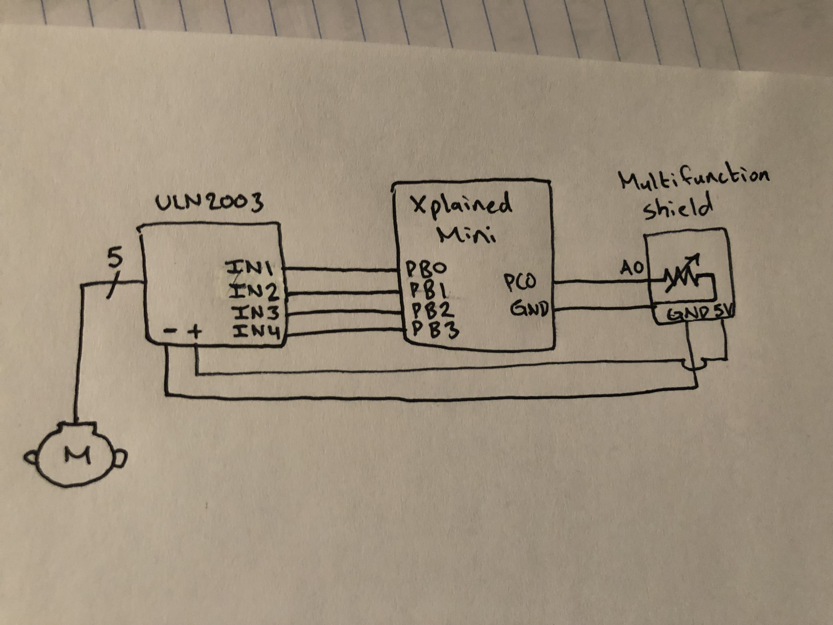

*Figure 3 – Schematic of Stepper Motor and Potentiometer ADC*

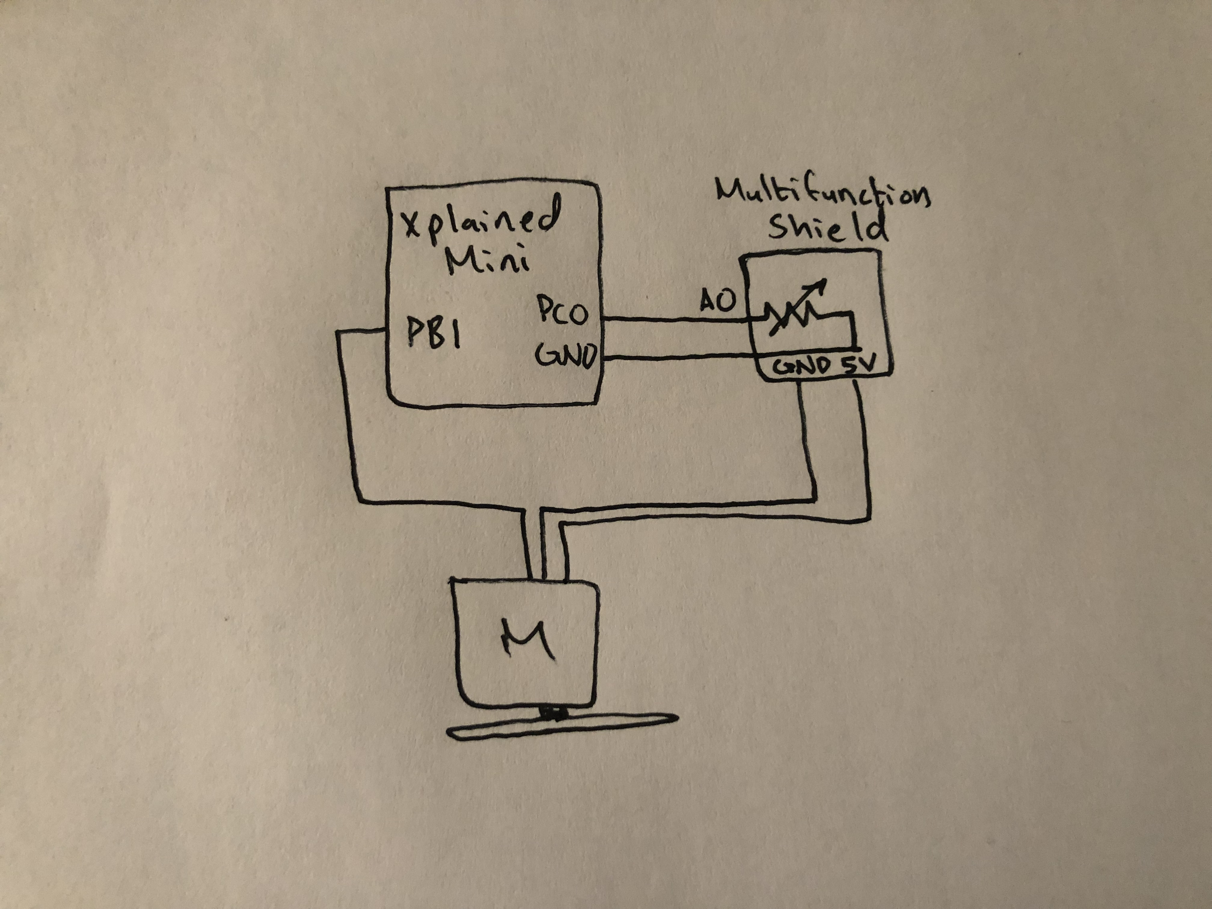

*Figure 4 – Schematic of Servo Motor and Potentiometer ADC*

1. **SCREENSHOTS OF EACH TASK OUTPUT (ATMEL STUDIO OUTPUT)**

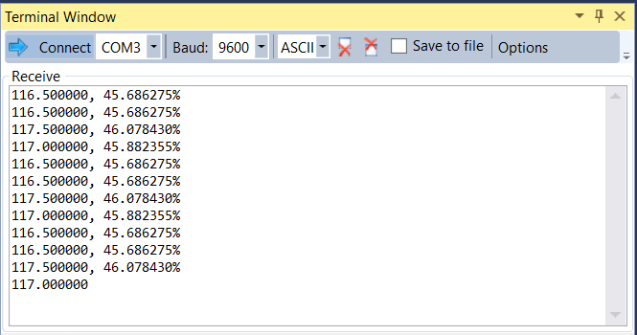

*Figure 5 – Output Terminal for Controlling Stepper Motor*

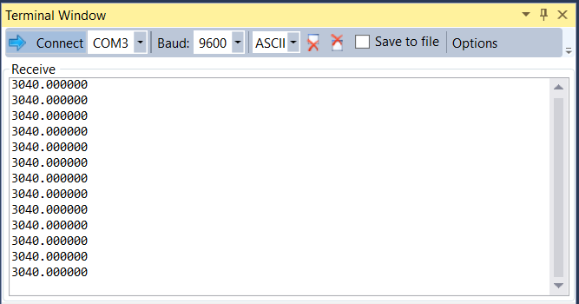

*Figure 6 – Output Terminal for Controlling Servo Motor*

1. **SCREENSHOT OF EACH DEMO (BOARD SETUP)**

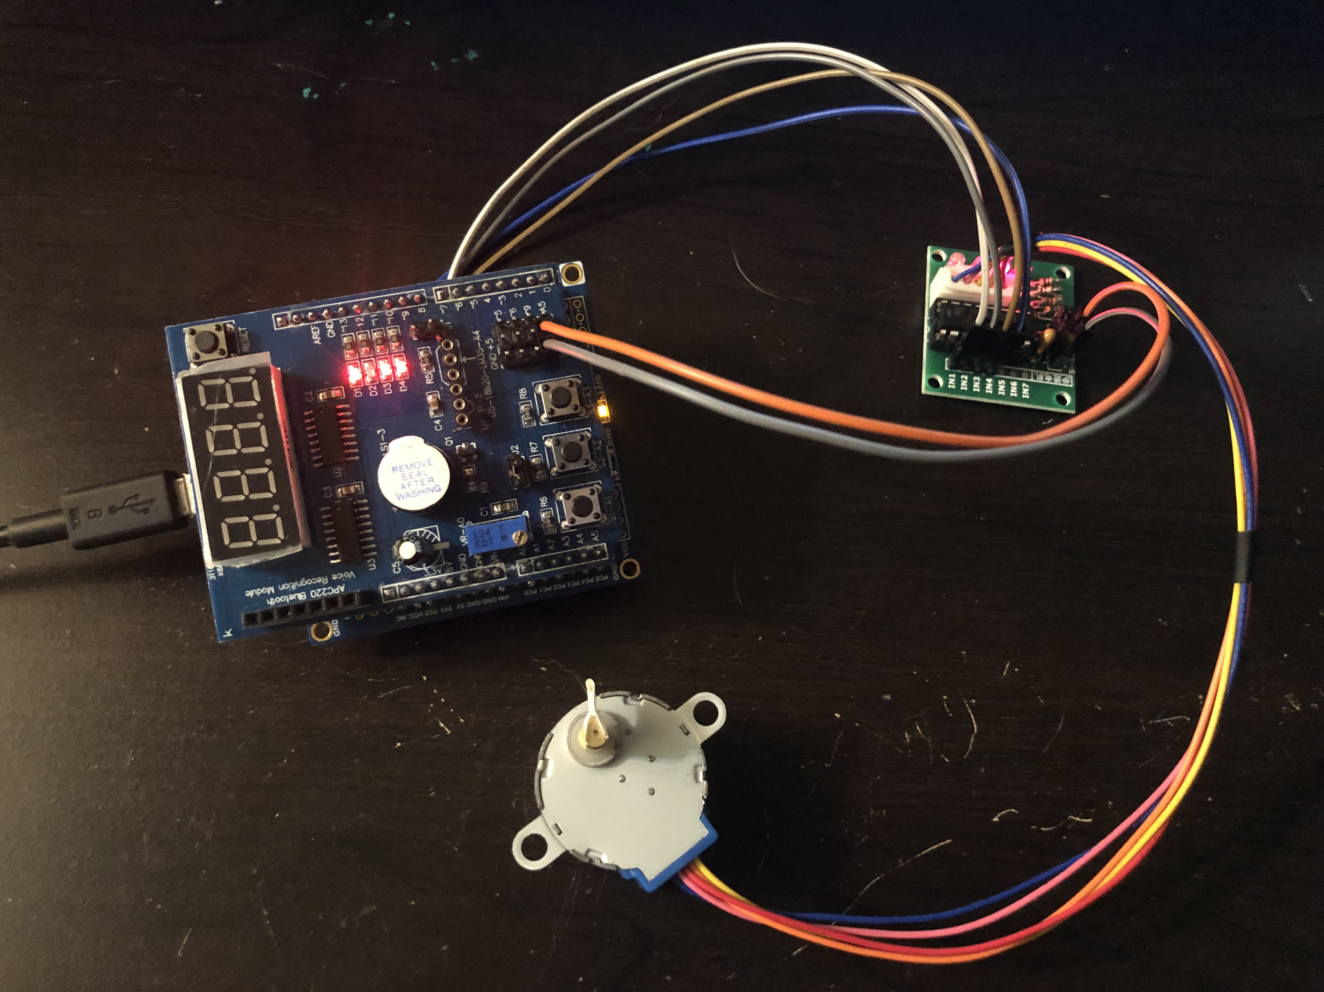

*Figure 7 – Connecting Stepper Motor to Potentiometer*

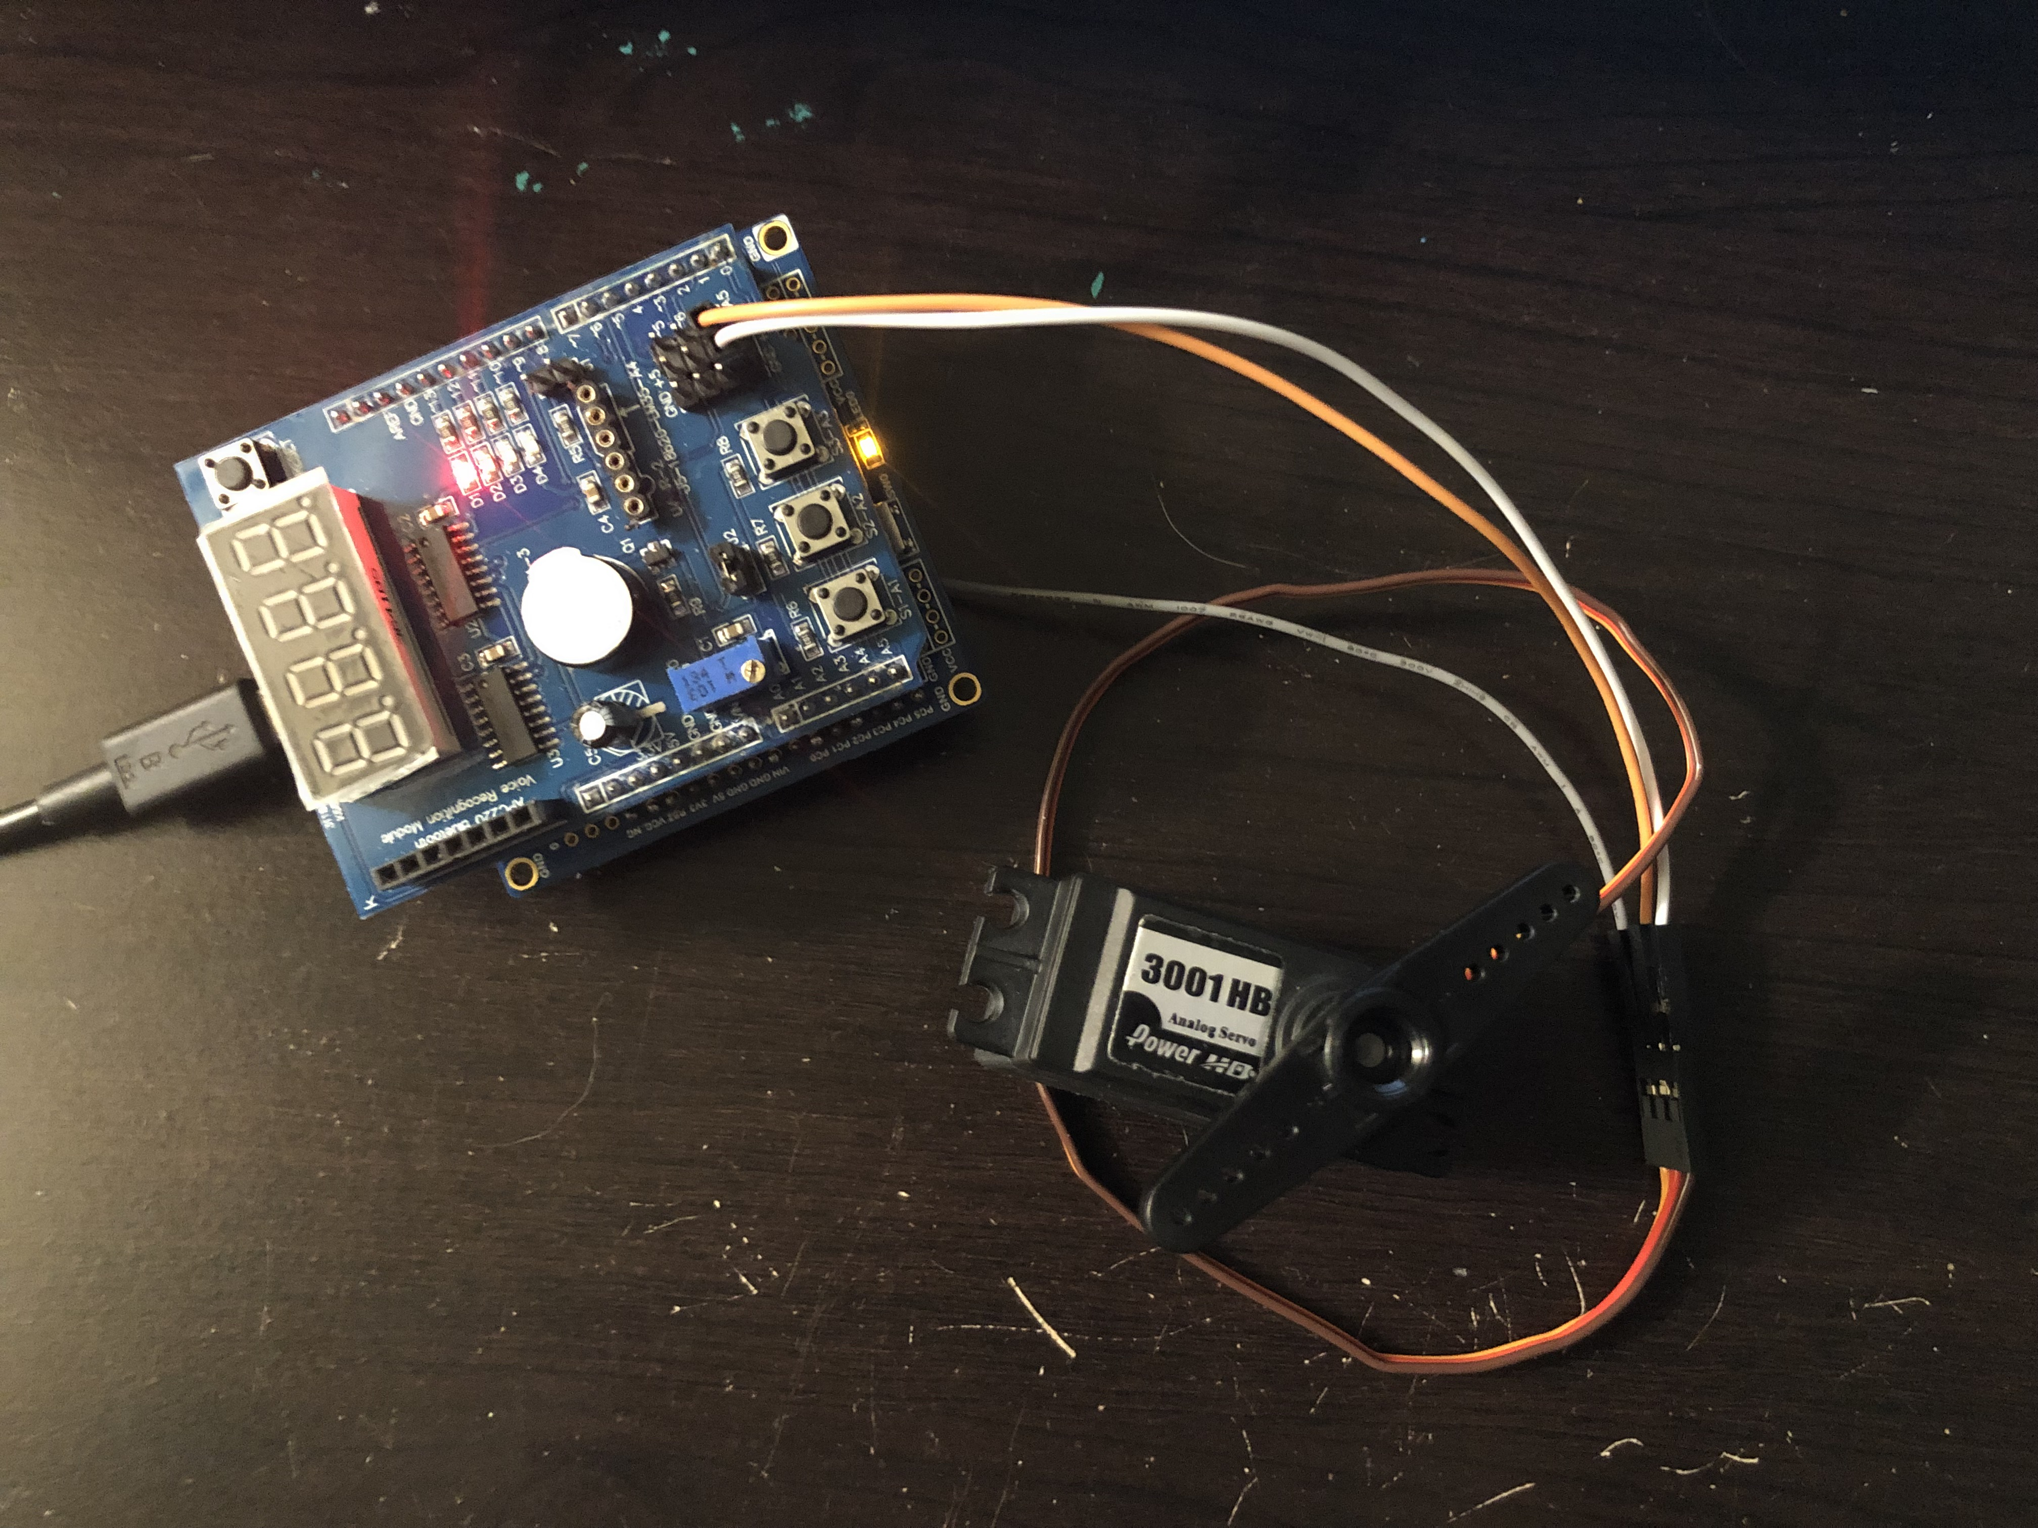

*Figure 8 – Connecting Servo Motor to Potentiometer*

1. **VIDEO LINKS OF EACH DEMO**

https://youtu.be/CwPMm-LuCxk

1. **GITHUB LINK OF THIS DA**

https://github.com/rockyg1995/ihswppdar/tree/master/DesignAssignments/DA4B

**Student Academic Misconduct Policy**

<http://studentconduct.unlv.edu/misconduct/policy.html>

“This assignment submission is my own, original work”.

Rocky Gonzalez